DESCRIPTION / SCOPE |  | PRODUCT LISTINGS |  | PRODUCTION PROCESS
${csProcessRisk_Group_Description} |  | ${csProcessRisk_Group_Listing} |  | ${csProcessRisk_Group_Process}

STORAGE CONDITIONS |  | SHELF LIFE |  | CCPS IDENTIFIED IN GROUP
${csProcessRisk_Group_StorageConditions} |  | ${csProcessRisk_Group_ShelfLife} |  | ${csProcessRisk_Group_CcpsPresent}

CURRENT HACCP TEAM
Name | Department | Qualification | Role
${csProcessRisk_Team_R}${csProcessRisk_Team_Name} | ${csProcessRisk_Team_Department} ${csProcessRisk_Team_Designation} | ${csProcessRisk_Team_Qualifications} | ${csProcessRisk_Team_Role}

HACPP GROUP FLOW
${csProcessRisk_Flow_File:height=20cm:width=18cm}

CCP Decision Tree
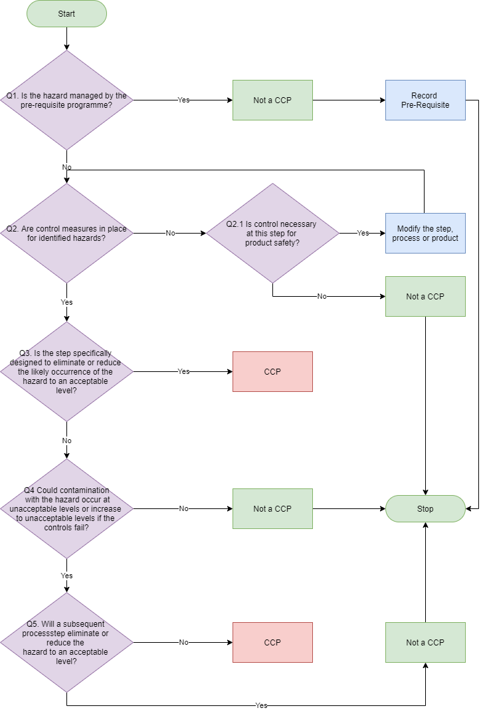

  Likelihood Levels will be determined using the following definitions
  Risk Level | Definition
  ${csProcessRisk_Rating_L_R}${csProcessRisk_Rating_L_Level} = ${csProcessRisk_Rating_L_Value} | ${csProcessRisk_Rating_L_Description}
  Risk Level x Severity Level = Hazard Score
   | 1 | 2 | 3 | 4 | 5
  1 | 1 | 2 | 3 | 4 | 5
  2 | 2 | 4 | 6 | 8 | 10
  3 | 3 | 6 | 9 | 12 | 15
  4 | 4 | 8 | 12 | 16 | 20
  5 | 5 | 10 | 15 | 20 | 25
  Severity Levels will be determined using the following definitions
  Risk Level | Definition
  ${csProcessRisk_Rating_S_R}${csProcessRisk_Rating_S_Level} = ${csProcessRisk_Rating_S_Value} | ${csProcessRisk_Rating_S_Description}
  Hazard Score RPN Level
  1 – 2 | Low
  3 – 4 | Medium
  5 – 12 | High
  15 – 20 | Very High
  25 | Extreme

PROCESS STEPS
Name | Description
${csProcessRisk_Steps_R}${csProcessRisk_Steps_Name} | ${csProcessRisk_Steps_Description}

PRE-REQUISITE PROGRAMME
Name | Description
${csProcessRisk_Reqs_R}${csProcessRisk_Reqs_Name} | ${csProcessRisk_Reqs_Description}

HAZARD ANALYSIS
Process Step |  | Hazard Type | Potential Hazard | Risk Rating  [L x S = RPN] | Pre-Requisites | Control measures | Q1 | Q2 | Q3 | Q4 | Q5 | CCP? | CCP ID
${csProcessRisk_Hazard_R}${csProcessRisk_Hazard_ProcessStepNo} | ${csProcessRisk_Hazard_ProcessStep} | ${csProcessRisk_Hazard_HazardType} | ${csProcessRisk_Hazard_Hazard}  ${csProcessRisk_Hazard_HazardDescription} | ${csProcessRisk_Hazard_HazardLikelihood} x ${csProcessRisk_Hazard_HazardSeverity} = ${csProcessRisk_Hazard_HazardRisk} | ${csProcessRisk_Hazard_HazardPrerequisites} | ${csProcessRisk_Hazard_HazardControls} | ${csProcessRisk_Hazard_CcpQ1} | ${csProcessRisk_Hazard_CcpQ2} / ${csProcessRisk_Hazard_CcpQ3} | ${csProcessRisk_Hazard_CcpQ4} | ${csProcessRisk_Hazard_CcpQ5} | ${csProcessRisk_Hazard_CcpQ6} | ${csProcessRisk_Hazard_CcpOutcome} | ${csProcessRisk_Hazard_CcpId}

CRITICAL CONTROL POINTS
Process Step Number |  | CCP ID | Control Measures/Pre-Requisites | Critical Limits(s) | Monitoring | Corrective Action(s) | Record(s) Used
${csProcessRisk_CCP_R}${csProcessRisk_CCP_ProcessStepNo} | ${csProcessRisk_CCP_ProcessStep} | ${csProcessRisk_CCP_CcpId} | ${csProcessRisk_CCP_CcpMonitorWhat} | ${csProcessRisk_CCP_CcpCriticalLimits} | Frequency  ${csProcessRisk_CCP_CcpMonitorWhen}  Responsibility  ${csProcessRisk_CCP_CcpMonitorWho}  How  ${csProcessRisk_CCP_CcpMonitorHow} | ${csProcessRisk_CCP_CcpCorrectiveActions} | ${csProcessRisk_CCP_CcpRecords}

