Borg & Overström

Audit Report

ISO 9001 GAP Analysis | 09/12/2024

This report and all its contents are confidential.

Section 1: Basic audit data
Client/Address | Client ID#
Thermaglow Limited | BOR006
Synergy House, Fakenham Rd, Morton on the Hill | Audit Criteria
Norwich | ISO 9001 / Q001
NR9 5SP | Date(s) of audit
Daniel Ulrich <daniel.ulrich@borgandoverstrom.com> | 09/12/24 to 10/12/24
Audit Activity | GAP Analysis
Audit Team
Lead Auditor | Robert Low | Audit-Day(s): 2
Observer (if needed) |  | Audit-Day(s):
Interpreter (if needed) |  | Affiliation:

Audit Applicability
Standard 1 | ISO 9001:2015

Scope of certification (if applicable specify scope for each site and each standard)

Audit Attendees
Name/Job Title | Name/Job Title | Name/Job Title | Name/Job Title | Name/Job Title

Section 2: Overall Results

No Action Required
The management system was found to be fully effective (no nonconformities issued)

Action Required
The management system was found to be effectively implemented although minor nonconformities were cited.

Immediate Action Required
The management system was found to be ineffectively implemented due to major/critical nonconformities cited.

Section 3: Executive summary
Strengths | Compliance demonstrated in areas that have undergone some changes in the last 12 months such as the introduction of the NPI process
Weaknesses | A Critical, Major NCR and a high number of Minor NCRs were raised at this visit demonstrating that there has been significant slippage in compliance. Stock control and traceability is a significant weakness for “non-primary” materials such as bolts, screws and pins, after issue from stores.
Opportunities | Opportunities raised as OFIs the Findings section
Threats | The critical finding raised should be dealt with immediately to ensure legal compliance is met

Section 4: Findings summary
See below findings for further details.
 | Critical Issued | Major Issued | Minor Issued | OFI Issued | # Total NC’s
ISO 9001:2015 | 1 | 29 | 22 | 25 | 77
Total | 1 | 29 | 22 | 25 | 77

Findings
Finding Ref | Audit Criteria | Clause | Classification | Details
#150424-1 | ISO 9001:2015 | 4.1/4.2 | OFI | Consideration should be given to how GL 00-001 & GL 00-002 document is used as a live document going forward and kept up-to-date
#150424-2 | ISO 9001:2015 | 4.4 | OFI | Considerations should be given to the process diagram showing the PDCA groupings, as stated in the manual
#150424-3 | ISO 9001:2015 | 4.4 | OFI | Considerations should be given to each process, whereby the associate procedures are recorded to link the system together
#150424-4 | ISO 9001:2015 | 4.4 | OFI | Considerations should be given to each process, whereby the associate process owner is recorded to link the system together
#150424-5 | ISO 9001:2015 | 4.4 | OFI | Considerations should be given to each process, whereby the associate objectives/metrics are recorded to link the system together
#150424-6 | ISO 9001:2015 | 4.3 | Major | The certification scope should be documented, covering exclusions (of which there are none), facilities (of which there are currently 2 sites), and regions of intended sale (Countries, platforms)
#150424-7 | ISO 9001:2015 | 5.2 | Minor | The statement regarding objective frameworks should be reviewed to state the framework and not a just state “framework” (It could be as simple as stating: 'We are committed to setting quality objectives that align with our strategic direction. The objectives are established, communicated, measured, and reviewed at least annually or when changes to the business and system occur')
#150424-8 | ISO 9001:2015 | 5.2 / 5.3 / 7.3 / 7.4 | Major | The quality policy should be displayed on staff notice boards where it is easy to read
#150424-9 | ISO 9001:2015 | 7.1.5 | Major | A procedure should be generated to cover preventative maintenance
#150424-10 | ISO 9001:2015 | 7.1.5 | Minor | Procedure PF 40-014 should be revised to ensure content is accurate to current activities
#150424-11 | ISO 9001:2015 | 7.1.6 | Minor | The quality manual should make reference to what competitors are doing such as conferences, presentations, academia in the knowledge section
#150424-12 | ISO 9001:2015 | 7.1.6 | OFI | A formal process for capturing knowledge should be considered and documented in the manual
#150424-13 | ISO 9001:2015 | 7.2 | Major | A procedure should be written to ensure training and competency is understood and consistent through out the organisation.
#150424-14 | ISO 9001:2015 | 7.3 | Major | Within the temp induction document FA 30-007, there is no references to the QMS, the quality policy, sickness reporting and training (based on the checklist document
#150424-15 | ISO 9001:2015 | 7.3 | Major | Within the perm induction document FA 30-007, there is no references to the QMS, the quality policy, sickness reporting and training (based on the checklist document)
#150424-16 | ISO 9001:2015 | 7.3 | Major | A procedure should be generated to cover staff inductions and the process of conducting them.
#150424-17 | ISO 9001:2015 | 7.4 | Minor | The quality manual should be updated to cover the following: reflect the omitted aspects in section 7.4, The approach to how Objectives and policies are communicated should be listed in the manual in 7.4, consideration should be given on how Monday.com is used as a communication tool and documented in 7.4 and As MRM minutes are not generated, the statement regarding MRM minutes should be removed.
#150424-18 | ISO 9001:2015 | 7.5 | Minor | The “Responsibilities” section of each procedure should be reviewed and amended to add key procedure responsibilities where applicable. Currently, for the most part, they state the creation and update of the procedure only.
#150424-19 | ISO 9001:2015 | 7.5 | Minor | The revision number and revision date should be included into each document header and the previous revision date removed for clarity. Currently this is left in and is confusing.
#150424-20 | ISO 9001:2015 | 7.5 / 5.3 | Major | The designation “Operations manager” should be removed from every document as this is no longer an active role within the company. The responsibilities should be reassigned where applicable to ensure no conflict on interest
#150424-21 | ISO 9001:2015 | 7.5 | OFI | Consideration should be given to list each procedure within the relevant section of the manual, where applicable
#150424-22 | ISO 9001:2015 | 7.5 | Major | The “checked by” and “Approved By” columns are not always completed for each document in the document register. This should be completed for each document.
#150424-23 | ISO 9001:2015 | 7.5 | Critical | There is no process, list, review or ownership of applicable legislation in place, leaving the company exposed to change in legal noncompliance.
#150424-24 | ISO 9001:2015 | 7.5 | Major | A procedure should be generated to cover document control and control of records which should include document types and storage controls for each type, preservation, back up and protection controls for each type & disposal methods.
#150424-25 | ISO 9001:2015 | 8.3.1 | OFI | Considerations should be given to each project on what the applicable legislation and regulatory requirements are for both the product and the internal manufacturing
#150424-26 | ISO 9001:2015 | 8.3 | Major | Clause 8.3 in the quality manual is stating as not applicable. This needs to be addressed, as it is applicable.
#150424-27 | ISO 9001:2015 | 8.3 | Minor | FA 85-017 (Design/Customer information capture) uses a non-approved/non-standard template. This does not show the version number. This document should be updated to align with the document control procedure, once created.
#150424-28 | ISO 9001:2015 | 8.4 | Minor | The supplier procedure should be updated to state what the mandatory acceptable criteria is for questionnaires
#150424-29 | ISO 9001:2015 | 8.4 | Minor | Supplier questionnaire FA 50-004 is designed for suppliers only. It is not appropriate for services providers even though it is being used for them.
#150424-30 | ISO 9001:2015 | 8.5 / 8.6 | Major | Complete Goods In procedure and train out
#150424-31 | ISO 9001:2015 | 8.5/8.6 | OFI | Recording specific goods in checks and tests should be considered
#150424-32 | ISO 9001:2015 | 8.4 | Minor | The supplier review procedure PD 50-007 should be updated to reflect current activities such as the use of Monday.com
#150424-33 | ISO 9001:2015 | 8.5.2 | Major | On the traceability challenge, there was a discrepancy of 5 units unaccounted for through the “Waste” mechanism recorded on the production documentation.
#150424-34 | ISO 9001:2015 | 8.5.2 | Major | Full traceability should be built into the goods in, production, goods out and storage system
#150424-35 | ISO 9001:2015 | 8.5.2 | OFI | Considerations to a full traceability procedure should be given
#150424-36 | ISO 9001:2015 | 8.5.3 / 7.5 | Minor | Section 8.5.3 of the quality manual should be updated to reflect the true status of 3rd-party property
#150424-37 | ISO 9001:2015 | 8.5.4 | Minor | There is no mention in the quality manual in regard to preservation of handling, packaging, contamination control, commingling control, internal storage, shelf life control of perishable items, transmission or transportation, and protection etc... These should be added to the manual to show a full understanding of preservation.
#150424-38 | ISO 9001:2015 | 8.5.4 | OFI | Considerations should be given to site cleaning records being put in place. As well as inter-site transportation pre checks
#150424-39 | ISO 9001:2015 | 8.5.5 / 8.6 | Major | The despatch/Delivery/Goods Out procedure should be generated, covering all delivery aspects and inter-site transfers. Potential to merge with the goods in procedure
#150424-40 | ISO 9001:2015 | 7.5 / 9.1.2 | Major | The date for the customer complaints procedure (2022) and the date recorded in the document register (2018) do not match and should be amended
#150424-41 | ISO 9001:2015 | 9.2 | Major | Clause 8.3 must be internally audited by an independent, competent auditor.
#150424-42 | ISO 9001:2015 | 9.2 | OFI | Considerations should be given to documenting the frequency and risk of the process on the audit plan and add this into the procedure
#150424-43 | ISO 9001:2015 | 9.2 | OFI | Review the need for additional internal auditors, including the Quality manager who is currently not trained but is the process owner
#150424-44 | ISO 9001:2015 | 9.2 | OFI | Blanks in the internal audit report should be denoted with either data or NA, where applicable, to show that it has been considered
#150424-45 | ISO 9001:2015 | 9.3 | Minor | The management review procedure requires updating as the documented procedure does not reflect the activities carried out – use of Monday.com
#150424-46 | ISO 9001:2015 | 9.3 | Minor | The management review meeting should be chaired by the senior leadership team with data and support from department heads such as quality, not chaired by quality, as this is a senior management meeting
#150424-47 | ISO 9001:2015 | 9.3 | Major | Evidence to support the management review meeting agenda is being followed and actions are generated from the agenda points should be put in place
#150424-48 | ISO 9001:2015 | 10.2 | Minor | The placeholder for the non-Conformity section in the quality manual needs updating to reflect the actual procedure, once created.
#150424-49 | ISO 9001:2015 | 10.2 | Major | Generate a procedure to cover non-conforming products and services as well as materials.
#150424-50 | ISO 9001:2015 | 10.2 | Major | A procedure should be generated to cover the management of corrective and preventative actions.
#150424-51 | ISO 9001:2015 | 10.3 | Minor | A procedure should be generated to cover the management of recall, withdrawals and incidents. This could be merged with the traceability procedure.
#150424-52 | ISO 9001:2015 | 5.1 | Minor | Section H of the Quality Manual in regard to director responsibilities should be changed to “overall responsible for the QMS and its effectiveness”
#150424-53 | ISO 9001:2015 | 5.1 | OFI | Considerations should be given to a documented quality culture plan being developed and implemented This could including effective inductions, employee suggestions, one-point lessons, communication of audit results, communication of complaints, random culture assessments on the shop floor
#150424-54 | ISO 9001:2015 | 5.3 | Minor | The organisation chart should be updated to explicitly state which positions are considered “Top management”
#150424-55 | ISO 9001:2015 | 5.3 | OFI | Considerations should be given to ensure the organisation chart is not misleading in any way
#150424-56 | ISO 9001:2015 | 5.3/7.2/7.3 | Major | Job descriptions and inductions records should be easily retrievable.
#150424-57 | ISO 9001:2015 | 6.1 | OFI | Considerations should be given to adding a column to the risk and opportunity register in Monday.com to state the source of the R/O (Internal or external) and the positive or negative state.
#150424-58 | ISO 9001:2015 | 7.1 | Minor | Equipment MIT393, Scale SN AE938425 and Micrometer S/N 230800580 should be controlled as per the calibration procedure and linking equipment containers to the equipment for calibration traceability
#150424-59 | ISO 9001:2015 | 7.4 | OFI | Considerations should be given in regard to the communication boards around the sites to review their content and suitability.
#150424-60 | ISO 9001:2015 | 7.4 | OFI | Considerations should be given to the applicability of signage and notifications around site
#150424-61 | ISO 9001:2015 | 7.5 | Minor | Add a change log to record what alterations are made to records and SOP/WI
#150424-62 | ISO 9001:2015 | 7.5 | Major | The method of providing hard copies of procedures to production should be reviewed to ensure that only active documents are stored and used at all times. This should be incorporated into the document control procedure.
#150424-63 | ISO 9001:2015 | 7.5 | OFI | Considerations should be given to adding a section to all procedures and SOPS that indicates if the revisions required training records to be updated
#150424-64 | ISO 9001:2015 | 8.5.1 | OFI | Consideration should be given to improving the documentation to show if a work station is required or not. This could be in the form of a column stating “Required station” or some other applicable example. The routing should be clear
#150424-65 | ISO 9001:2015 | 8.5 | OFI | Considerations should be given to labelling up the work stations with clear signage as opposed to hand written, ambiguous text.
#150424-66 | ISO 9001:2015 | 8.5 | OFI | Considerations should be given to the use of shadow boards on site.
#150424-67 | ISO 9001:2015 | 8.5/7.5 | OFI | Considerations should be given to the use of ditto marks on controlled documentation.
#150424-68 | ISO 9001:2015 | 8.5/7.5 | Major | A large number of hard copy SOPs stored in production are the incorrect revision. All obsolete versions of records should be removed from production and replaced with the correct, controlled version. This is across both sites
#150424-69 | ISO 9001:2015 | 8.5/7.5 | Major | Control of documentation and records should be put in place through formal procedures which allows for control of physical documents and change request notification
#150424-70 | ISO 9001:2015 | 8.5.2 | Minor | All traceability labels that fall off of goods should be immediately placed back on the item
#150424-71 | ISO 9001:2015 | 8.5.4/7.1 | OFI | Considerations should be given to tiding up the external yard and despatch areas
#150424-72 | ISO 9001:2015 | 8.7 | Major | All nonconforming materials and products should be labelled up so as to identify the disposition of the goods, as well as the intended control step (segregation, containment, return, dispose of etc…)
#150424-73 | ISO 9001:2015 | 8.7/8.5.4 | Major | All bags of waste powder should be sealed shut and then labelled up
#150424-74 | ISO 9001:2015 | 8.5.1 | Major | The production of the solder rings should have documented controls in put in place to ensure conformance to specification and traceability
#150424-75 | ISO 9001:2015 | 9.2 | Minor | Conciderations should be given to conduciting more audits, as per the schedule of requriements
#150424-76 | ISO 9001:2015 | 8.5.2 | Major | A large number of goods were observed around both sites to be in trays, bags or other containment materials but had no stock item or traceability information of them, resulting in loss of traceability.
#150424-77 | ISO 9001:2015 | 8.5 / 7.5 | Major | Considerations should be given to amending FA 60-044 to remove the printed days of the week and allowing for the dates to be manually entered in a left to right format

Section 5: Evidence Summary
The evidence of the state of the management system is summarized below
Requirement | Outcome / Gaps
4.0 Quality Management System Scope
4.1 Identifying Stakeholders
Has the organization created and maintained a record of internal and external stakeholders who are affected by, or have an effect on, the organization’s products, services and/or quality management system? | Stakeholders are recorded in GL 00-001 & GL 00-002 which was last updated 7/3/2022  Conciderations should be given to how this document is used as a live document going forward and kept up-to-date
Do external stakeholders include customers and suppliers at a minimum? | Yes
Do internal stakeholders include employees and top management at a minimum? | Yes
4.2 Identifying Stakeholders’ Concerns and Requirements
Has the organization created and maintained a record of the concerns and requirements of the stakeholders identified in 4.1? | Stakeholders concerns are recorded in GL 00-001 & GL 00-002 which was last updated 7/3/2022
4.3 Quality Management System Processes
4.3.1 Internal Processes
Has the organization determined the processes within the scope of the quality management system? | Yes. A process diagram in recorded in the quality manual, under section F.  The flow diagram shows from customer enqurery to customer satisfaction.  The process diagram should show the PDCA groupings, as stated in the manual  For each process, process preocedures should be recorded to link the system together  For each process, process owners should be recorded to link the system together  For each process, process objectives/Metrics should be recorded to link the system together
Has the organization prepared a documented process definition for each process which defines:  … a) the process owner(s)? | No
… b) a general description of the process flow and how it interacts with other processes? | Yes. This is in place.
… c) process quality objectives as text statements defining the intended purpose of the process? | Not in place
… d) process metrics as the data to be collected and measured in order to determine if the process quality objective is being met? | Not in place
Do the process owner(s) then oversee the measurement of the process metrics? | Not in place
Based on this data, has top management established goals for these process quality objectives? | Objectives are documented on Monday.com but are not fulyl SMART for clear which are quality objectives and which are business objectives. This are not linked to processes.
When a process does not meet the goals, does top management take suitable action? | Actions for objectives are recorded in Monday.com and are communicated at the MRM meetings
Are changes to internal processes be performed in accordance with the change management requirements of 6.2? | Not in place – See Managemet of Change
4.4 Quality Management System Scope
Has the organization documented a scope statement that defines the locations, products, services, and processes to be included in the quality management system? | There is no documented evidence of the scope. There is a section in the manual (4.3) but this does not explicitly state the scope.  The certification scope should be documented, covering exlusions (of which there are none), faciltities (of which there are currently 2 sites), and regions of intended sale (Countries, platforms)
Does the scope statement indicate a justification as to why any clause of this standard is to be excluded? | Yes – 8.3 but this is incorrect as 8.3 is in scope
Are clauses only excluded when the organization’s activities do not include the activities covered by the clause? | NA
5.0 Quality Management System Leadership
5.1 Management Commitment
5.1.1 Demonstration of Management Commitment
Does top management demonstrate its commitment to leading and improving the quality management system by: a) documenting how it takes accountability for the effectiveness of the quality management system? | There is a quality policy in place, however the quality manual isnt explicit in where senior leadership is accountable for the QMS. In section H of the quality manual, the second paragraph states the directors are responsible for providing the neessary personnel and resoruces to suppoer the effective and efficient performance of the core business. This should be changed to “overall responsible for the QMS and its effectivness”  Section H of the Quality Manual in regards to director responsiblities should be changed to “overall responsible for the QMS and its effectivness”
… b) providing evidence of participation in quality system planning activities? | Sign off given to conduct this GAP analysis was given the the MD
… c) signing the quality policy? | The policy is signed by the MD PD
… d) providing evidence of participation in management reviews (see 9.3)? | The management review, as per the procedure, is chaired by the Q & E Manager – See 9.3. However participation of the senior leadership team is in place.
… e) reviewing and analyzing quality data (see 9.1.2)? | Action tracker and presentations are available in regards to the use of data analysis in Monday.com
… f) communicating the quality culture? | No quality culture plan is in place. Staff not aware of the quality policy and have little awarness of ISO 9001 and the QMS. Awareness of basic quality aspects is known however.
… g) providing evidence of how it manages, leads and supports subordinate staff? | In place through the organisation chart and demonstratable through conversations
5.1.2 Quality Culture
Has top management adopted and implemented a culture of quality that focuses on satisfying the customer’s requirements? | There is no documented quality cutlure plan in place. Quality culture is only obvious at management levels.  Shop floor staff have little knowledge on quality
Is the definition of this culture and the plan for its implementation documented? | Not in place but not required by ISO 9001.  Conciderations should be given to a documented quality cutlure plan being developed and implemented This could including effective inductions, employee suggestions, one point lessons, comunication of audit results, communication of complaints, random culture assessments on the shop floor
5.2 Quality Policy
Has top management developed, documented and published a quality policy that: a) summarizes the organization’s culture of quality? | The quality policy is in Section D of the quality manual and located on main entrance notice boards around the two sites.  There was no evidence of the wuality policy being displayed on staff notice boards.  The quality policy should be displayed on staff notice boards where it is ease to read.  The statement regarding objective frameworks should be reviewed to state the framework and not a just state “framework”  The quality policy was last reviewed 19 December 2023 as indicated on the document..
… b) is easily understood? | In place
… c) is relevant to the organization and its products or services? | The policy is relevent but generic
5.3 Responsibilities and Authorities
Has the organization documented who is considered “top management” and thus responsible for the requirements of top management called out by this Standard? | The companies organisation chart is in palce in section G of the quality manual. With the MD at the top. The operations director is responsible for sales, H&S and marketing. The quality and Eingineering manager is responsible for ISO 9001/Quality and maintenance, the techinical manager is responsible for projects.  The overall organisation chart is hard to read and doest explicitly state who is concidered “Top Management”. The chart also has names and designation with boxes of a similar shape stating some core responsibilities which is are to denote and can be misslead you into thinking that is a separate person.  The organisation chart should be updated to explicitly state which positions are concidered “Top management”.  Conciderations should be given to ensure the organisation chart is not missleading in any way
Does top management include the senior-most manager(s) responsible for the organization, giving consideration of the scope limitations defined per 4.4? | Not in place. Finding raised previously.
Does top management ensure that responsibilities relative to the quality management system are defined and documented? | Although is was siad that job descriptions were in place, these were not able to be produced as evidence.  Job descriptionsand induction were not easily retreavable when requested.
Does top management ensure that personnel have the necessary authority to carry out their responsibilities? | Staff are generally given a degree of autonomation to carry out their day to day activities with support given through meetings and actions documented.
6.0 Quality Management System Planning
6.1 Risk and Opportunity Management
6.1.1 Approach to Risk and Opportunity Management
Has the organization determined its approach to managing risks and opportunities, and define this in a documented procedure? | Section 6.1 of the quality manual documents the actions to address risk and opportunities through monthly supplier meetings, monthyl sales meetings and management review meetings. Other conciderations are given through strategies, objectives, compliance, performance data and lessons learnt.  An extensive and live risk register is in aplce and is recorded on Monday.com  Risks range from new equipment to support required.  Risks are assigned to staff members with deadlines on actions recorded to mitigate.  The risk register does not state the internal or external source of the risk/opportunity, neither does it state if it’s a risk, opportunity or both.  Conciderations should be given to adding a column to the risk and opportunity register in Monday.com to state the source of the R/O (Internal or external) and the positive or negative state.
7.0 Quality Management System Support
7.1 Resources
7.1.1 Resource Provision
Does top management promote a culture that allows staff to request resources related to the quality management system? | There appears to be a lack of quality culture in place however staff are aware of what is needed to be done to get the job done at the required level. Resources include new equipment, staff and materials/
7.1.2 People
Has the organization provided employees, contractors, staff, temporary help, etc., necessary for the effective implementation of the quality management system processes, and/or to ensure quality of products and services? | The org chart is in place and shows growth over the last year with some restructures and new personnel hired. The quality and technical teams appear to be well staffed to conduct activities.  There is a need for additional internal auditors through as ther eare 4 trained auditors but only 2 available for use.
7.1.3 Infrastructure
7.1.3.3 Preventive Maintenance
Is the preventive maintenance program defined in a documented procedure? | No procedure is in place for the manaement of preventative maintenance . Procedure PD 40-014 is in place for reactive maintenance, however this needs attention as the process states the use of spreadsheets where as Monday.com is not used.  A procedure should be generated to cover preventative maintenance  Procedure PF 40-014 should be revised to ensure content is acurate to current activities
Are records of preventive maintenance maintained? | Records are in place and logged on Monday.com
7.1.3.4 Tooling
Are tooling, jigs, fixtures and other support devices identified to distinguish them from product, if such confusion is likely? | Tools are left lying around the enviroment and a lack of control in obvious.  Shadow boards are in place but on no occasion were they used correctly.  Jobs are used to set lines up as per the production requirement
7.1.4 Work Environment
Has the organization provided and maintained the work environment necessary for the quality management system processes, and/or ensure quality of products and services? | The work enviroment is generally acceptable such as temperature, heat, humidity, lighting, air quality, ventelation etc… however there was a few occasions wherea door was brken and in need of replacement but not communicated, wire housing detaching from walls and the external condition of the yard with waste uncontrolled for the chemcial powder.
7.1.5 Inspection and Testing Resources
7.1.5.2 Calibrated Inspection and Testing Devices
Are inspection and testing devices used to accept or reject products or services calibrated in accordance with a documented procedure? | Procedure PD-07-014 is in place for calibration however this needs updating as the proecures refers to the use of spreadsheets where as Monday.com is now used.  Procedure PF 07-014 should be revised to ensure content is acurate to current activities  Equipment observed:  MIT393 – Out of Calibration Exp 29/11/2023  MIT 268 Exp 11/7/2024  Scale S/N AE938425 No calibration or MIT ref  Micrometer Out of Calibration S/N 230800580 Exp 2/4/24 No MIT Ref  MIT260 Exp 19/7/2024  Equipment MIT393, Scale SN AE938425 and Micrometer S/N 230800580 should be controlled as per the calibration procedure.
Does the calibration procedure include: a) a definition of the calibration frequency for each resource? | Frequencies are listed in the Monday.com table with frequencies specific to each item type (Scales = Yearly)
… a) who will perform the calibration for each device (e.g., the organization or an approved supplier); | The responsible party is listed in the Monday.com table
… b) how devices will be uniquely identified to trace back to the calibration records; | Unique MIT references are used through out for each equipment
… c) how devices will be identified with their current calibration status, so that users know when they are overdue; | Labels are applied to each item with the MIT reference for traceability
… d) how such devices are to be protected from mishandling, damage or deterioration that would invalidate the calibration. | Any damaged equipment is handed to the quality nad engineering deaprtmetn for review with the reactive Maintenance procedure being followed. Out of Clibration equipment is first red tagged so it is not used and then investigated.rectified where possible. New equipment purchased is handed to quaility before being introduced to the site. This is where MIT references and logs are created.
Are records of calibration maintained? | Records are maintained on Monday.com with the above examples observed
7.1.6 Knowledge
Has the organization determined the knowledge necessary for the quality management system processes, and/or ensure the quality of products and services? | Quality manual section 7.1.6  Knowledge is listed as being gained from employee experience, lessions learned, successful projects, improvements in processes, customer satisfaction, supplier meetings and customer meetings.  The quality manual makes no references to what competitors are doing, confrences, presentations, academia in the knowledge section  The quality manual should make reference to what competitors are doing such as confrences, presentations, academia in the knowledge section
Has the organization implemented methods to reduce the loss of such knowledge when changes to staff occur? | There are informal discussions taking place that discus the loss/change in staffing levels. This sincludes on site training programmes.  A formal process for capturing knowledge should be concidered and documented.
7.2 Competence & Training
Does training include applicable quality management system documentation for the position? | There is no real QMS awareness training however, training is job specific.
Does the organization maintain a documented procedure defining its training program? | No documented Procedure is in place.  A procedure whould be written to ensure training and competency is understood and concistant through out the organisation.
Are records of training maintained? | Training records for production are hand written and stored in a filling cabenet, under lock and key.  Employee skill traiing matrix on Monday.com is under development. This is currently in place for procurement & logistics, with production and other deaprtment due to be included shortly.  The new matrix covers, digital recording of training, review dates and outcomes/evaluations. The introduction of this new approach is a perfect opportunity to formally procedurelaise the process.
7.3 Awareness
Does training also include initial orientation and periodic re-training on: a) the quality policy (per 5.2)? | Induction for temp staff using FA 30-007 – Within the temp induction document FA 30-007, there is no references to the QMS, the quality policy, sickness reporting and training (based on the chicklist document)  Induction for perm staff using FA 30-008.  – Within the document there is no references to the QMS, the quality policy and sickness reporting (based on the chicklist document)  The activity is conducted by department managers with no formal procedure in place. This could mean that the approach and content of using the checklist can be different from one person to the next. Induction plan and checklist procedure FA 30-002 is listed on the docuiment register but the link doesn’t work. A formal procedure should be developed to ensure consistince in the process.  The manual states that training will be continually appraised through out the training period, but the training period is not defined and the approaisals are not formally documented.
… b) the organizational quality culture (per 5.1.2)? | No
… c) each person’s relevant process quality objectives (per 4.3)? | No
… d) each person’s contribution to the quality management system? | No
… e) how to report quality management system problems and nonconformities? | Not specifically
Are there records of the awareness training? | In the induction form which are stored in the production managers office under lock and key for production, and the rest in the personal files.
7.4 Communication
7.4.1 Internal Communication
Has the organization ensured that methods are implemented to allow internal communication in all directions (i.e. management to staff, staff to management, staff to staff, between processes, etc.)? | Quality manual section 7.4  Internal communication is driven from informal verball discussions, emails, general meetings and communication boards.  One point lessons are used to drive internal communication.  The quality manual should be updated to refelect the omited aspects in section 7.4  The approach to how Objectives and policies are communicated should be listed in the manual in 7.4  Concidereation should be given on how Monday.com is used as a communcation tool and documented in 7.4  As MRM minutes are not generated, the statement regarding MRM minutes should be removed.  There are a number of staff notice boards around the two sites. It was observed that a large number of these have obstructed content or the content is so old (cira 2007) that its possible that staff don’t use them as active communication tools.  Conciderations should be given in regards to the communication boards around the sites to review their content and suitability.  Signage around the site is confusing and over cluttered. Examples include:  - signage for mandatory wearing of safety glassses and ear plugs that is in the heart of production as opposed to the entrance to production where it is more valuable. On top of this, staff were not following this.  - Cluttering of paperwork on walls that is covered in dust and overlayered making some documents unreadable  - Some notice boards are obstructed by doors or equipment  Conciderations should be given to the applicability of signage and notifications around site
7.5 Documents and Records
7.5.1 Development of Documents and Records
Has the organization developed documents and records to support and the quality management system processes? | A qulity manual is in place as well as supporting documents.
Does this include documented procedures and records required by this Standard, as well as any required by the organization itself? | There is no formal procedure in place.  A procedure should be generated to manage how documents are controlled through out.  The “Responsibilities” section of each procedure should be reviewed and amended to add key procedure responsibilities where applicable. Currently, for the most part, they state the creation and update of the procedure only.  The revsion number and revision date should be included into each document header and the previous revision date removed for clarity. Curently this is left in and is confusing.  The designation “Operations manager” should be removed from every document as this is not longer an active role within the company. The responsibilities hsould be reassigned to the Qualtiy and Engineering manager.  Concideration should be given to list each procedure within the relevent section of the manual, where applicable  Quality manual is in place  Section 1 of the manual should have the second site added to the applicabiliy sites.  The exclusion for 8.3 should be removed as 8.3 Design and development is in scope.  There is no reference to applicable legislation in the responsibilities Section (Section H)  In section H, for the directors responiiblities, it should state the overall responsibility of the QMS is the responsibility of the directors.  In Section H, after director responsibilities, it states that procedures are approved by the director in line with the standard, this should be chaged to “in line with document procedures”  The operations manager responsibilties in section H should be reallocated  Conciderations should be given to adding a section to all procedures and SOPS that indicates if the revisions required training records to be updated
7.5.2 Control of Documents
Has the organization developed a documented procedure which defines how documents are: a) drafted? | There is no document procedure but there is a quality manual, section 7.5 but this is basic. A document register is in place which should the reference, date of author, author and version.  The “checked by” and “Approved By” columns are not always completed for each document in the document register. This should be completed for each document.  There is no process, list, review or ownership of applicable legislation in place, leaving the company exposed to change legal non compliance.
… b) reviewed? | No review period is stated for each procedure in the document register.
… c) approved? | No details are in place that state this
… d) published? | No details are in place that state this
… e) revised? | No details are in place that state this
Are all quality system documents which instruct subject to this procedure? | No details are in place that state this
Are records of document approval and release maintained? | No details are in place that state this
Are quality system documents subject to revision control? | No details are in place that state this
Where feasible, do revised documents have a means of identifying the changes made to the document? | A change log is recorded within the document but it doesn’t appear as if there is a change log on records.  Add a change log to record what alterations are made to records and SOP/WIs
Are all documents readily available where they are needed by staff? | Documents are avilable to staff in both digital and hard copy.  On the production floor, at the main site, a filing cabinet is present that holds hard copies of the procedures. The front of the draw has a sign stating that staff much check the version of the document against the document register prior to using the document but provides no method of doing this. Additionally, the documents should not be in the draw if they are not the active version of the document.  The method of providing hard coplies of procedures to production should be reviewed to ensure that only active documents are stored and used at all time. This should be incorporated into the document control procedure.  Hard copy procedures in productio ncheck  L070 Issue 1 14-Dec-18 – Correct Version  B110 issue 1 30-Oct-18 – Incorrect – Correct version is v2 30/7/21  B104 issue 1 19-Jun-20 – Incorrect verion - Correct version is v2 30/7/21  L010 Issue 1 13-Dec-18 – Correct  B080 Issue 2 30-Oct-18 – Incorrect Version – Correct version is v3 29/7/21  B102 v1 26-Nov-18 – Incorrect Version – Correct Version is v2 30/7/21  B081 v 2 30-Oct-18 – Incorrect verion – Correct version is v3 29/7/21  A large number of hard copy SOPs stored in production are the incorrect revision and need to be removed immediately
7.5.3 Control of Records
Has the organization developed a documented procedure which defines how records are: a) created? | No procedure in place  A procedure should be generated to cover document control and control of records
… b) filed? | The documents are stored in both hard copy and digital on the server.  There is no mention of document types or storage controls for each type.
… c) preserved, including backup and protection of electronic records? | There is no mention of document types or preservation, back up and protection controls for each type.
… d) retained, including minimum retention times? | There is no mention of document types or storage controls for each type.
… e) disposed of? | There is no mention of document types or disposal controls for each type.
8.0 Operation
8.1 Operational Process Planning and Control
Before work commences, does the organization ensure that operational processes are included in the defined quality management system processes (see 4.3), and that the process objectives, metrics and controls are adequate and implemented? | Qualtiy manual, section 8.1 covers how this is managed.
If statistical process control is to be implemented, are the methods defined in a documented procedure? | Not used
Are statistical process control techniques statistically valid and/or based on published and industry-accepted methods? | NA
8.2 Capture and Review of Requirements
8.2.1 Capture of Requirements
Is the capture of requirements performed in accordance with a documented procedure? | Customer Orders/Quotes:  If a new product, NPI procedure PD 75-001, This procedure covers new product development, NPI #10 UK Innovations  If existing, procedure PD 09-007 technical order prcedure, purchase orders are used for existing products along with existing specification documents via stock item references  Specification documents are created for every new product with the help of specalist software, and approved by the customer. A folder is then created on the server.  Production Planning:  Production for is managed through a number of systems and tools including Sage 50 for sales order and excel  for production scheduling and planning.  The production plan excel document generates the unique batch number for the job against the part number and  sales order. Batch numbers are built from the iteration of job in the year, the week number of the year and a letter  to represent the year.  - SO 39378, ECN5731 batch 4116A (41st job of the year, 16th week of the year, A = 2323) TL Order 39378  drawing red 23.4426.04  Production job packs are then created using the excel controlled templates based on the job required.  The job packs include the following documents: Drawings (if required), Sales order, working instructions,  traceability tickets and inspection history record  - TL 9481, batch 2418A drawing 23.1269.01 reviewed  The documents are printed off and placed in the "Post bag", and given  to the production supervisor.  Once complete, the records are collected for review and scanning/storage.  The originals are then disposed of in waste paper & cardboard bins - Production record being completed - Batch 3614A 23.3460.00 Sales Order 3802 5 x 3 pcs  The production plan is on Monday.com with a stage check box selected as and when the job progresses through each operation stage.
Does the capture of customer requirements include: a) requirements provided by the customer directly? | Yes
… b) requirements not provided by the customer, but known to the organization as being applicable? | Yes
… c) related statutory and regulatory requirements related to the product or service? | Conciderations should be given to each project on what the applicable legislation and regulatory requirements are for both the product and the internal manufacturing
… d) information from any applicable prior work? | Yes
Are all such requirements recorded prior to review? | Yes via the NPI
8.3 Design
8.3.1 Design Approach
Has the organization defined its approach to design activities in a documented procedure? | Procedure PD 75-001 New product innovation is in place.  The design approach is documented in the procedure as a flow chart. Extensive conciderations are given to planning, requirments, inptus, outputs, validation and verification aspects.  Responsibilities are listed as on the forms “nominated project manager” and Project team/stakeholders  Clause 8.3 in the quality manual is stating as not applicable. This needs to bne addressed, as it is applicable.  Technical review form FA 75-014 & FA 85-017 are used to document this.  FA 85-017 uses a not approved/non-standard template. This does not show the version number
8.4 Purchasing and Subcontracting
8.4.1 Evaluation and Approval of Suppliers & Subcontractors
Does the organization evaluate and approve suppliers of materials, products and support services in accordance with a documented procedure? | Procedure in Place PD-50-006  Procedure covers on the process whereby supplier are approved based on a criteria within a questionnaire or audit.  Step 3 within the procedure references the review of the quenstionaire for accetability but doesn’t specify what the acceptable criteria are. There is a new supplier interface manual in development which should aid this.  A full approved supplier register is in place with due dates recorded.  The supplier procedure should be updated to state what the mandatory acceptable criteria is for questionnaires  Supplier questionnaire FA 50-004 is designed for suppliers only. It is not approporeaite for services providers even though it is being used for them.
Does this include any subcontractors, including those used to support quality management system activities? | Yes
Are records maintained of suppliers, the approval status and their scope of approval? | Yes In supplier specific folders
In all cases, has the organization retained final responsibility for products or services provided by suppliers or subcontractors? | Yes.
8.4.2 Purchasing
Does the organization conduct purchasing of items and services in accordance with a documented procedure? | Procedure in Place PD-50-005
Does the organization only purchase items and services from suppliers who have been evaluated and approved? | Yes
Where the organization purchases test items or services for evaluation purposes, is the temporary supplier approval condition recorded? | No
Does the organization provide the supplier with a purchase request for the items or services to be purchased? | Purchase Orders are used which are generated through Sage
Do such purchase requests include, at a minimum: a) description of the items or services to be purchased? | Yes
… b) any required delivery dates requested by the organization? | Yes
… c) any applicable organizational requirements related to the item or service? | Yes
… d) any applicable statutory or regulatory requirements related to the item or service? | NA
Are records of purchases, including the purchase requests, retained? | Records are retained for 10 years.
8.4.3 Subcontracting
Where the organization subcontracts activities or services, is this done in accordance with a documented procedure? | Procedure in Place PD-50-006 for supplier acceptance  The only subcontracted activity is carried out by Kepston Limited who are recorded on the approved supplier list. An audit was conducted against them in Jan 2021 however the hyperlink does not work
Does the organization use contracts or other documents to define the required services to be provided by subcontractors and outsourced process providers? | Specifications and job sheets are used to provide the subcontractor with the requried details to carry out the job.
8.4.4 Verification of Received Items or Services
Are purchased items or services verified as conforming to requirements before used by the organization? | Items are verified by the technical team as part of the NPI process.
Are verification of received items and services performed in accordance with a documented procedure? | No procedure is currenly in place, however there is a draft procedure that needs completing and training out  Complete Goods In procedure and train out
Are records of the verification of received items or services maintained? | Records of goods in are entered into Sage as GRNs but specific checks are not recorded. CoCs are logged on the system  Recording specific goods in checks and tests should be concidered
8.4.5 Ongoing Evaluation of Suppliers
Does the organization perform ongoing evaluation of suppliers and subcontractors to monitor their performance in accordance with a documented procedure? | Supplier review and performance procedure is in place PD 50-007 as an on-going process but generally weekly  The supplier review procedure should be updated to relflect current activities such as the use of Monday.com
Is the level of evaluation and control over each supplier determined based on the criticality of the supplier and/or the products or services provided? | Evaluations are recorded on the Supplier register
Does the organization advise the supplier when performance is found to be unacceptable, and work to resolve the issue with the supplier or disqualify them from future purchasing consideration? | Routine meetings are held with key suppliers whereby performance is communicated.
Are records of supplier evaluation and actions taken maintained? | On the supplier register
8.5 Production and Service Provision
8.5.1 Control of Production and Service Provision
8.5.1.1 Production and Service Controls
Has the organization provided production and service personnel with the appropriate controls to ensure work is performed which meets requirements? | Production records in place and used at each stage of operation. Each stage has its own associated procedure/SOP which is listed on the production documentation at the relevent stage.  When production fill out the records, due to some work stations not being needed to complte the job, the production records can appear incomplete.  Concidersations should be given to improving the documentauton to show if a work station is required or not. This could be in the form of a column stating “Required station” or some other applicable example  When carrying out work station specific ativities, it is not always clear what the work station is the activitiy is being carried out on due to a lack of clear work station identification.  Conciderations should be given to labelling up the work stations with clear signage as apposed to hand written, ambigeous text.  Shadow boards are used in production but on no occasion was a shadow board observed as being used correctly or complete.  Conciderations should be given to the use of shadow boards on site.  Production Records  During the walk around, record FA 7-010 was being used in the coil room. This record had ditto marks in the “reject” column which could have been interpreted as the number “11”.  Conciderations should be given to the use of ditto marks on controlled documentation.  Record FA 70-030 (Resistance record) showed signs of being a scan of a scan due to its deteriated quality. It was then noted by the Q&E Manager that this was not even the correct document version.  All obsolete versions of records should be removed from production and replaced with the correct, controlled version.  A physical copy of procedure FA 60-001 v4 B020 16/8/23 was in the coil room which did not state the need to record the results in the record.  A physical copy of procedure B040 v1 07/02/2022 was in the coil room which has a hand written alteration at step 420.  Control of documentation and records should be put in place through formal procedures which allows for control of physical documents and change request notification  The production of solder rings has no records or specification in place to control the operation, its in-process controls or final output and as it can be sold as a final product there is no evidence of traceability in place.  The production of the solder rings should have documented controls in put in place to ensure conformance to specification and traceability  Production records reviewed for the following:  ECN 8084 Batch #5112C qty 55 units.  Run through work stations Set dual, windings, resistance, wash coils, pinning up, Hirst, welding, pull test and peelwith only 1 unit rejeced.  ECN 6754 Batch #7515C Qty 138 units.  Run throuigh Set Single, Winding, Resistance, Wash Coils with 3 units rejected.
8.5.2 Product Identification and Traceability
8.5.2.1 Product Identification
Does the organization identify product at all times to ensure it is not misplaced, commingled, or misidentified? | An Element Calculation Number (ECN) is generated for each product which is unique and used on documentation  A large number of goods were observed around both sites to be in trays, bags or other containment materials but had no stock item or traceability information of them, resulting in loss of traceability.
Are product identification methods defined in a documented procedure? | The quality manual states in section 8.5.2 identification and traceability but it is vague
8.5.2.2 Product Traceability
If individual product serialization, traceability and/or batch identification is required, does the organization implement appropriate methods to ensure this? | An Element Calculation Number (ECN) is generated for each product which, when producing products, has a batch number associated. R = year + ##=sequential job number + ## = week number i.e (R0731)  Materials are tagged with material labels wich show the sales order/PO, supplier and stock code.  Production jobs show each stage of operation, logging the batch numbers of assembled materials.  During the walkaround, it was identified at one of the tube storage areas, that a number of traceability labelles had fallen off the tubes leaving the tubes unidentifyable.  All traceabilty labels that fall off of goods should be immediately placed back on the item
Where serial or batch numbers are used, does the organization ensure these are not duplicated? | Unique status is ensured though the use of a spreadsheet and sequential numbering on the S Drive
Where necessary, do any records related to the product reference the individual product serial numbers or batch number for which the records refer? | Trace challenge conducted on:  Order 41771 ENC 4582 QTY 177 12 March 2024 Customer Froment Despatch 24 Apri 2024  Customer Purchase Order – 41711 for 177 units  Specification for 23055801 ENC4582 2/9/2010  Run batch record - Batch 6411C WO 41771 Batch qty planned 183 actual 177 (183 for loss and rejections) covering 9 stages  Started at 190 and ended up at 177. However there is a descrepency on rejects for 5 units missing.  On the traceability challenge, there was a descrepency of 5 units unacconted for through the “Waste” mechamisum recorded on the production documentation.  BOM covers 11 items  Use of 02-1113 wire using GRN 17510 185 units  Powder GRN 58281  Despatch note 112058 Despatch note 41771 12/3/2024  There is limited recorded tracability on the raw materials agaisnt production runs to allow for effective recall and traceabiltiy.  Full traceability should be built in to the goods in, production, goods out and storage system
Are product traceability methods defined in a documented procedure? | The quality manual states in section 8.5.2 identification and traceability but it is vague  Conciderations to a full traceabiltiy procedure should be given
8.5.2.3 Configuration Management
Where the organization produces or works with assemblies or complex parts that require configuration management controls, are these controls implemented so that sub-components and sub-assemblies are traceable to the final assembly, and all applicable paperwork is representative of the configuration? Are configuration management methods defined in a documented procedure? | Each operational stage has its own associated procedures  Procedures are reviewed in section 7.5 with an action riased.
8.5.3 Control of Third-Party Property
Does the organization ensure proper handling, identification, protection, and preservation of property belonging to third parties, including customers or suppliers, when the organization has control over the property? | The quality manual states in section 8.5.3 how property belonging to customer and external providers is contolled. Primarly, the company states that no such property exists on site.  Mira equipment is stored on site which is controlled through calibration and maintenance records.  Section 8.5.3 of the quality manual should be updated to reflect the true status of 3rd-party property
Is the control of third-party property performed in accordance with a documented procedure? | The quality manual states in section 8.5.3 how property belonging to customer and external providers is contolled. Primarly, the company states that no such property exists on site.  Mira equipment is stored on site which is controlled through calibration and maintenance records.
8.5.4 Preservation
Does the organization preserve product at all times to the extent necessary to ensure quality? | Overall, based on the site walkaround, preservation is largely under control. Exceptions to this would be the condition of the yard and despatch areas, whereby they are in an un clean/unhygenic condition.  Conciderations should be given to tiding up the external yard and despatch areas.
Do preservation activities include handling, packaging, contamination control, commingling control, internal storage, shelf life control of perishable items, transmission or transportation, and protection? | There is no mention in the quality manual in regards to preservation of handling, packaging, contamination control, commingling control, internal storage, shelf life control of perishable items, transmission or transportation, and protection etc... These should be added to the manual to should a full understanding of preservation.
Are preservation activities defined in a documented procedure? | The quality manual states in section 8.5.4 how preservation is controlled.  Cleaning is conducted by a part-time operator and areas are maintained through general 5S control. No records are in place to document these activities.  Conciderations hould be given to site cleaning records being put in place. As well as intesite transportation pre checks
8.5.5 Delivery
Does the organization deliver completed products or services in accordance with applicable requirements? | Despatch is in place and carried out in accordance to applicable requirement such as customer address, method (packaging), documentation and identification.  Records reviewed  PO 86300 Batch 0315C Customer howdens  PO 17074 Batch # 7217C Customer Teal Patents Limited  Despatch records reviewed in trace challenge as well
Where appropriate, does the organization define delivery activities in a documented procedure? | Various customer packaging work instruction are in place (WI 50-077 Grant ENC5828)  There is no active goods out/despatch procedure currently.  The despatch/Delivery/Goods Out procedure should be generated, covering all delivery aspects and intersite transfers. Potential to merge with the goods in procedure
Are records of product service and delivery maintained? | Records reviewed in the tracabiltiy exercise
8.5.6 Post-Delivery Activities
Has the organization defined what post-delivery activities it is responsible for and perform them in accordance with all applicable requirements? | As required, Certificates of Conformity are generated where requested.  Customer complaints are managed through the complaints procedure (See customer satisfaction)  Customers are contacted for feedback (See customer satisfaction)
Where appropriate, has the organization defined post-delivery activities in one or more documented procedures? | The quality manual states in section 8.5.5 various activities including the ones above.
8.6.2 Receiving Inspection
Where deemed appropriate to meet the requirements of 8.4.4, is inspection or testing of received items or services performed? | Not carried out on delivery of goods. Material items are checked through out production assembly. Where defective, goods are quarrentined and supplier NCR raised.
8.6.5 In-Process Inspection
Where deemed appropriate, are inspections and/or tests of products being produced, or services being delivered, performed to ensure quality? | Production assemblies are inspected at most work stations along the assembly route. The requriements are listed in the associated records and limites in the specifications. These include checks such are resistance, length, Amps, Diameter, hook height, cut length, volts, watts (where applicable)
8.7 Control of Nonconforming Product or Service
8.7.1 General Control of Nonconforming Product or Service
Has the organization ensure that nonconforming product is not used or delivered? | Scrap NCM and NCP are generally placed into scrap bins for disposal. Scrpa bins observed during the walkaround were not seen to have been labelled up identifying the stock disposition or reason.  Quarrentined NCM & NCP are placed into the Quarrentine cage at the main site. The process is for items to be given a red tag stating the reason and clearly identifying the item as NC. Coils next to the cage had red tags on them but tubes inside and outside the cage did not. Infact they had not identification of any kind.  Bags of powder were seen being used as waste bins within the production area as well as a large scale of exposed bags of powder stored outside, on pallets. The bags had no identification on them and had spilled over the external yard floor blocking the drains. (Infactructure & Waste)  Outside, in the yard, there was a number of tubes which were deformed but also had no identification as to their desposition.  Where stock is identifiable, rejection records are in place denoting the soruce and reason.  All nonconforming materials and products should be labelled up so as to identify the disposition of the goods, as well as the indended control step (segregation, containment, return, dispose of etc…)  All bags of waste powder should be sealed shut and then labelled up  Routing cards for rework and hand written and approved by the quality team with links to the MRB which was rasied to document the situation. This is then given to production for usage in carrying out the job.  Grayson Order 40656, batch # 11022A, Drawing 23-0951-09
Has the organization maintain a documented procedure on the controls for nonconforming product or service, which covers how the organization complies with 8.7.2 and 8.7.3? | Not currently. This has been rasied in 10.2
9.0 Performance Evaluation
9.1 Monitoring, Measurement, Analysis and Evaluation
9.1.1 Overall QMS Evaluation
Does the organization evaluate the performance and effectiveness of the quality management system in accordance with a documented procedure? | The quality manual in section 9.1.1 covers the evaluation of the management system.  Covering the in MRM
9.1.2 Analysis and Evaluation
Does the organization analyze and evaluate quality system data related to the following, at a minimum: a) product / service quality? | The vast majority of the performance evaluations are driven from Monday.com dashboards and KPI metrics.  Production plan, Goods In, Goods Out hit rate.
… b) cost of quality? | Not currently being used but part of an ongoing CI process to introduce as part of the Material Review Board – Customer credit notes and Scrap costs (Cost of poor quality)
… c) customer satisfaction? | Customer complaints in Monday.com  Qty over month, MRBs by customer, despositions per month, reason for rejections, defects by category.  Customer satisfaction in quality manual, section 9.1.2. Stating repeat businees as a metric of gauging satisfaction.  Customer complaints procedure in place PD 70-026  The date for the customer complaints procedure (2022) and the date recorded in the document register (2018) do not match and should be amended
… d) process performance against the defined process quality objectives? | Objectives that are in place are logged in Monday.com and tracked on a routine basis.
… e) the performance of suppliers and subcontractors? | In place – covered in supplier approval. Logged in the supplier approval
9.2 Internal Audits
9.2.1 Purpose of Internal Audits
Does the organization conduct internal quality system audits to ensure the quality management system: a) conforms to the organization’s requirements and procedures? | In place
… b) conforms to the requirements of this Standard? | In place
… c) is effectively implemented and maintained? | In place
9.2.2 Conducting Internal Audits
Are internal audits performed in accordance with a documented procedure which covers how the organization meets all the requirements of clause 9.2? | Procedure PD 70-012 is in place and covers the internal audits  Internal audit programme in place using excel spreadsheet and covering all clauses – 2024 audit plan (clause by clasue, allocation of auditor, planned month, topic/scope, actual date of audit)  Approved auditors are listed in the top left corner of the audit plan.  The current 2024 audit plan has no allocation for clause 8.3 which was previously concidered an exlusion.  Clause 8.3 must be internally audited by an independent, competent auditor.  Conciderations should be given to documenting the frequency and risk of the process on the audit plan.  Internal audit reports in place on FA 70-011 and well maintained
Does the internal audit activity include planning of: a) the frequency of audits? | Not in place. Comment made regarding the update of the schedule to incorporate this aspect
… b) the scope of audits? | In place
… c) the internal audit method(s) to be used? | In place
… d) records to be completed? | In place
… e) the internal auditors assigned to each audit? | In place
Has the organization scheduled audits according to the results of prior audits, process performance issues, or other concerns? | Not in place. Comment made regarding the update of the schedule to incorporate this aspect
Does the frequency of internal audits ensure that all quality management system processes and/or clauses of this Standard are audited at least annually? | All clauses are audited once per year.
Does the organization maintain the schedule of internal audits as a formal record? | Yes howver there is only 1 audit condicted year to date.  Conciderations should be given to conduciting more audits, as per the schedule of requriements
Are internal auditors selected to ensure objectivity and the impartiality of the audits? | Yes – Auditor are objective and competent
Is training of internal auditors performed in accordance with requirements established by the organization per 7.2? | Auditor competencies  - James Babb - Cert 29079 Internal system auditing 26/02/2020 by Collin associates  - Nick Cable - Cert 28817 Internal system auditing 13/09/2018 by Colin associates  - Jess Bramhall - Cert 29080 Internal system auditing 26/02/2020 by Colin associates  - Darren Locke - Cert 28258 Internal system auditing 22/02/2017 by Colin associates  Due to restrictions in availabiltiy, only Nick and Darren are active auditors.  Review the need for additional internal auditors, including the Quality manager
9.2.3 Internal Audit Evidence
Do auditors gather and capture objective evidence to support audit findings? | Report reviewed  Technical audit 29-02-24 by Nick, with a list of procedure given, distrubution ot senior management recorded, out come was minor 0 major 0.  Infacstructure audit 03/5/2023 by Nick, no procedure in place - The outcome of the audit showed a number of minor non-conformances:  - On FA 60-044 there was no maximum tolerance listed for the pull test. Additionally, the the overall tolerances  could be clearer on the specification document.  - There is no GRN number written on the production documents  - Bending operation documents states to "bend as per the pattern", however no pattern exists. It was noted by the  internal auditor that the bend should be 45C and should be checked but there is no means of checking.  Blanks in the internal audit report should be denoted with either data or NA where applicable to show that it has been concidered
Do the findings of internal audits include: a) evidence of conformity? | Yes
… b) evidence of actual nonconformities (see 9.2.4)? | Yes
… c) evidence of potential nonconformities (see 9.2.4)? | Yes
… d) opportunities for improvement made by the internal auditors? | Yes
9.2.4 Reporting Internal Audit Nonconformities
Where either actual or potential nonconformities are reported, are these reported in a manner that includes the following three details: a) a clear description of the requirement (e.g., clause reference, procedure citation, etc.)? | Yes
… b) a clear description of the objective evidence reviewed or observed? | Yes
… c) a clear description of why the objective evidence shows the requirement was not met? | Yes
Do actual nonconformities require corrective action per 10.2? | Yes
Do potential nonconformities require preventive action per 10.3? | Yes
9.2.5 Internal Audit Reports
Are records of internal audit reports maintained? | Yes
Do these records contain at a minimum: a) the audit plan details per 9.2.2? | Yes
… b) evidence reviewed per 9.2.3? | Yes
… c) descriptions of nonconformities per 9.2.4? | Yes
9.3 Management Review
9.3.1 Management Review Approach
Does top management review the quality management system’s performance in accordance with a documented procedure? | Procedure PD 70-023 is in place covering the MRM  The management review procedure requires updating as the documented procedure does not reflect the activities carred out – use of Monday.com
Does the management review procedure define: a) the methods for management review? | Yes – however the procedure needs updating for statem the use of the current tools.
… b) the minimum frequency for management review? | Yearly as per the procedure (1 to 4 times a year as stated in the quality manual and procedure)  The management review meeting should be charied by the senior leadership team with data and support from department heads such as quality
… c) the minimum personnel required to attend the management review? | The required personnel are lsited in the procedure
… d) the topics to be reviewed at management review (see 9.3.2)? | An agenda is listed in the procedure covering the requirements of the standard however there is currently no mechanism to ensure this is followed  Evidence to support the agenda is being followed and actions are generated from the agenda points should be put in place
Is the management review conducted at a minimum annually? | Yes – Next review is planned for 15/5/2024
9.3.2 Management Review Requirements
At a minimum, does the management review include a review of the following aspects: a) necessary changes and updates to stakeholders (per 4.1)? | No evidence, as agenda is not documented and actions only lised for objectives
… b) necessary changes and updates to stakeholders’ issues (per 4.2)? | No evidence, as agenda is not documented and actions only lised for objectives
… c) risks and related mitigation plans (per 6.1.2)? | No evidence, as agenda is not documented and actions only lised for objectives
… d) opportunities and related pursuit plans (per 6.1.3)? | No evidence, as agenda is not documented and actions only lised for objectives
… e) process performance metrics (per 4.3)? | No evidence, as agenda is not documented and actions only lised for objectives
… f) customer satisfaction (per 9.1.2)? | No evidence, as agenda is not documented and actions only lised for objectives
… g) cost of quality (per 9.1.2)? | No evidence, as agenda is not documented and actions only lised for objectives
… h) performance of suppliers and subcontractors (per 8.4.1)? | No evidence, as agenda is not documented and actions only lised for objectives
… i) training effectiveness and related needs (per 7.2)? | No evidence, as agenda is not documented and actions only lised for objectives
… j) the adequacy of resources (per7.1)? | No evidence, as agenda is not documented and actions only lised for objectives
… k) trends related to corrective and preventive actions (per 10.2 and 10.3)? | No evidence, as agenda is not documented and actions only lised for objectives
… l) internal and external audit results (per 9.2)? | No evidence, as agenda is not documented and actions only lised for objectives
… m) status of incident investigations (per 10.4)? | No evidence, as agenda is not documented and actions only lised for objectives
… n) the status of actions from previous management reviews? | No evidence, as agenda is not documented and actions only lised for objectives
… o) changes to the organization or the quality management system? | No evidence, as agenda is not documented and actions only lised for objectives
… p) opportunities for improvement for the quality management system? | No evidence, as agenda is not documented and actions only lised for objectives
10.0 Improvement
10.1 Pursuing Continual Improvement
Does the organization pursue continual improvement of its products, services, and quality management system processes by: a) following up and updating the opportunities pursued as defined in 6.1.3? | Nonconformane procedure for general products (8.7) is not in place  Supplier NC procedure is in place PD 70-006  The quality manual states in section 10.2 procedure PD 070-XXX.  The placeholder for the Nonconformaty section in the quality manual needs updating to reflect the actual procedure, once created.  Generate a procedure to cover non conforming products and services as well as materials.  Opportunities are established through on going business activities and include such improvements as conducting a GAP analysis to establish an action plan. Introducing new method of working for staff. Adding new positions within the business.
10.2 Corrective Action
10.2.2 Processing Corrective Action Requests
Is the method for processing corrective actions defined in a documented procedure? | Corrective actions are managed through supplier NCRs only currently.  There is no procedure in place covering the control of Corrective actions  A procedure should be generated to cover the management of corrective and preventative actions.
10.3 Preventive Action
10.3.2 Processing Preventive Action Requests
Is the method for processing preventive actions defined in a documented procedure? | Preventative actions are managed through supplier NCRs only currently.  There is no procedure in place covering the control of Corrective actions  A procedure should be generated to cover the management of corrective and preventative actions.
10.4 Incident Investigation
Does the organization investigate any incident involving defective or nonconforming products or services delivered to customers or released to the market, whether reported by the customer, media reports, or other third parties? | No incident procedure is in place.  A procedure should be generated to cover the management of recall, withdrawalls and incidents.
At a minimum is the investigation performed according to the corrective action requirements of 10.2? | No
Does top management oversee the investigation and records maintained? | No

Audit Checklist – Photos
AREA
Photographical Evidence
WASTE
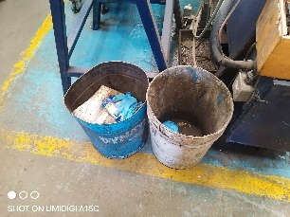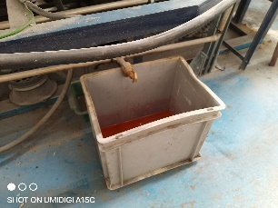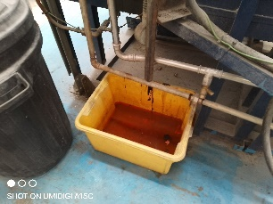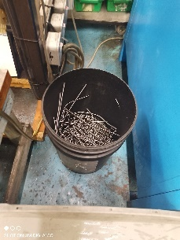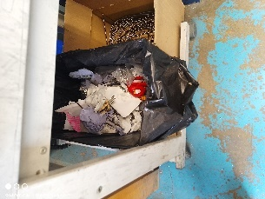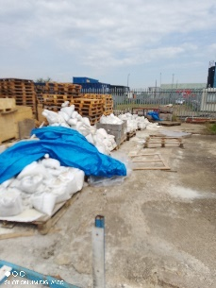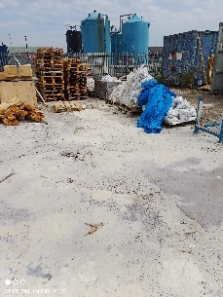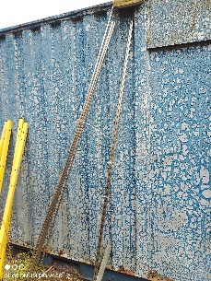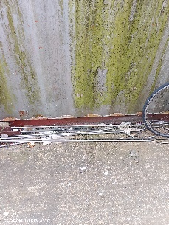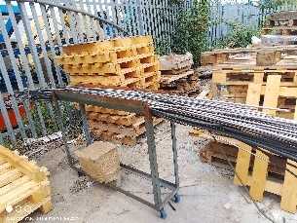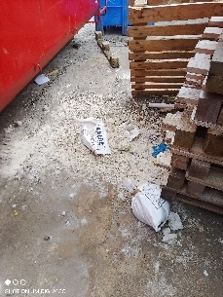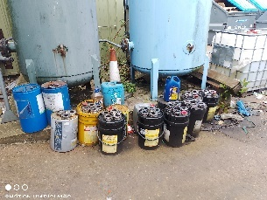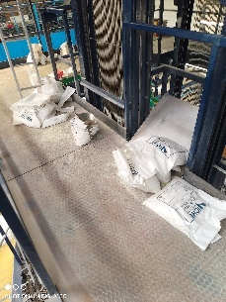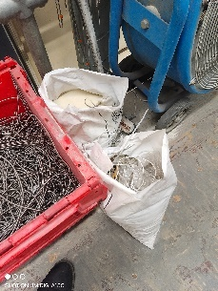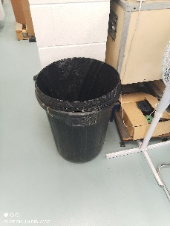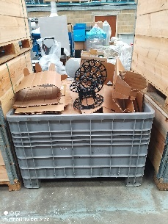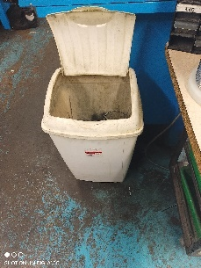
Waste bins not labelled up. Drip trays not labelled up. Waste not controlled exterior. Waste not controlled on top of filling platform.

Documentation
Procedures
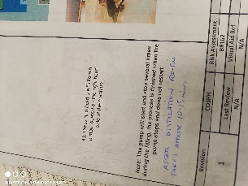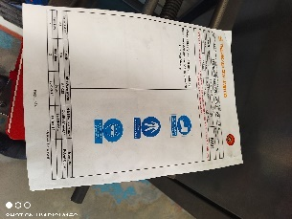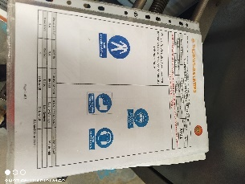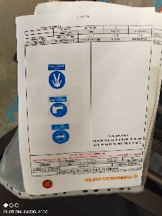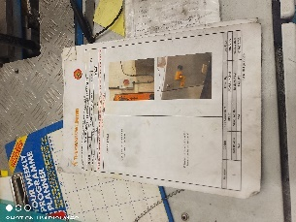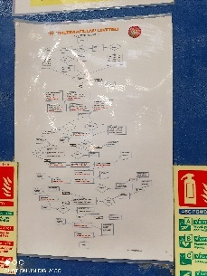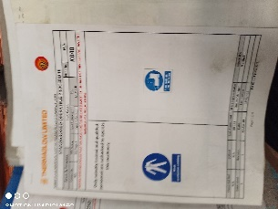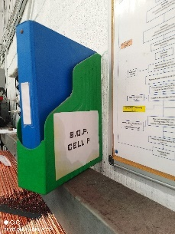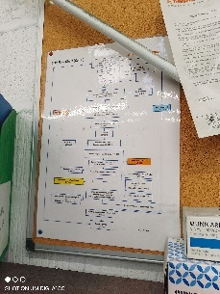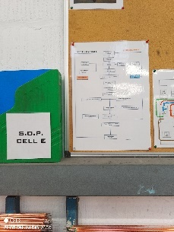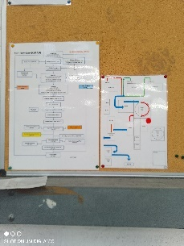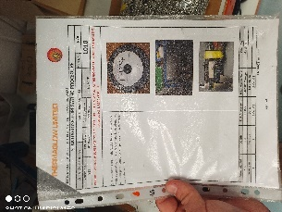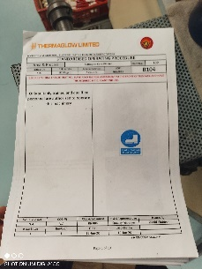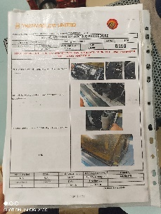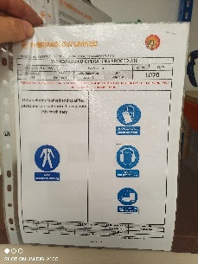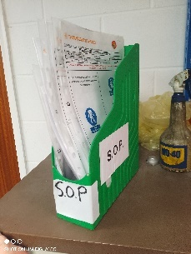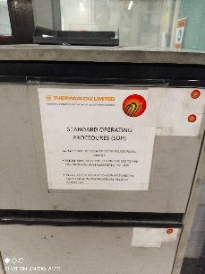

PRD Records
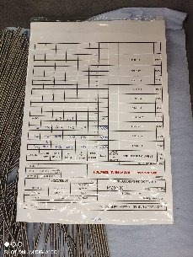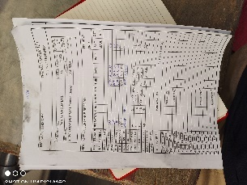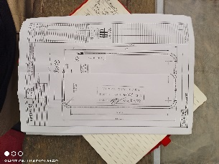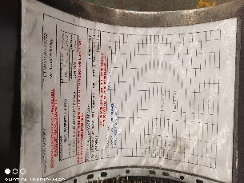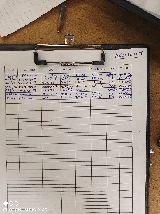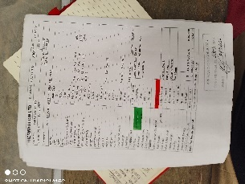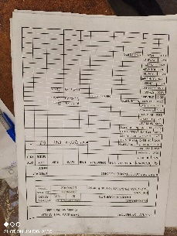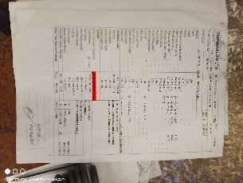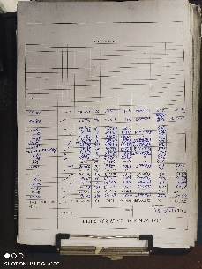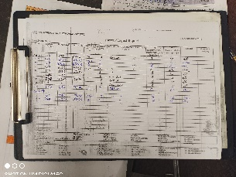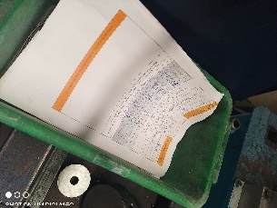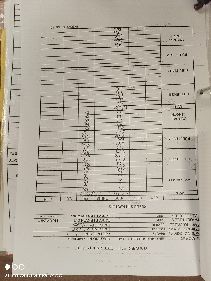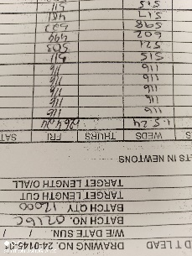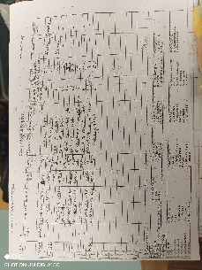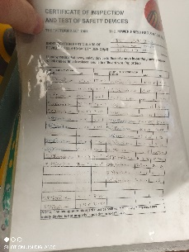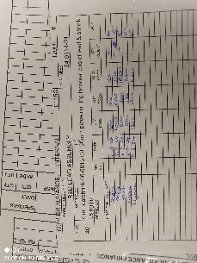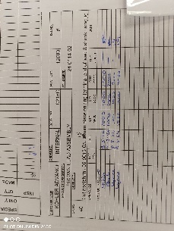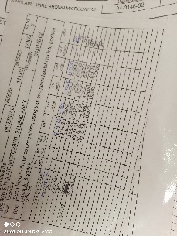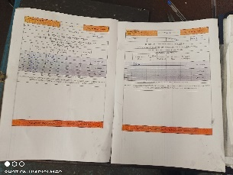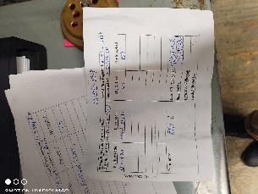
Production hard copy procedures. Production and site records
Equipment
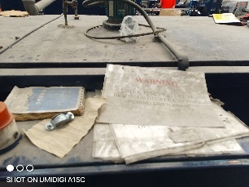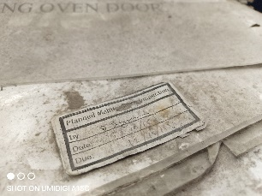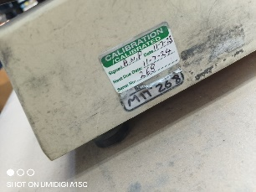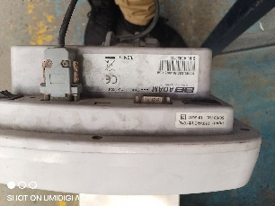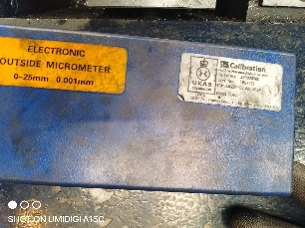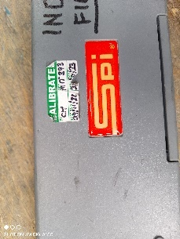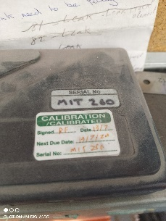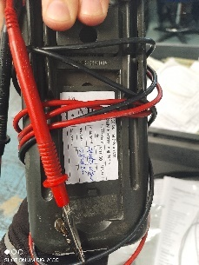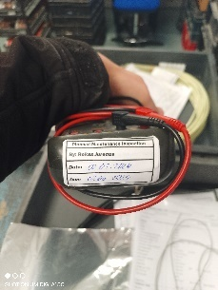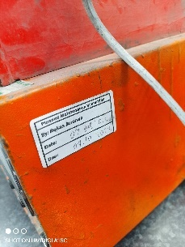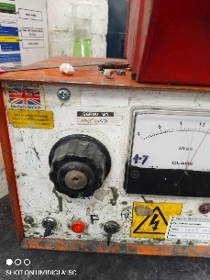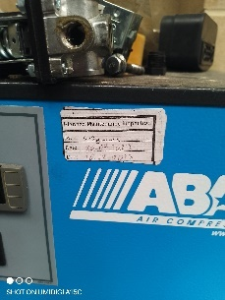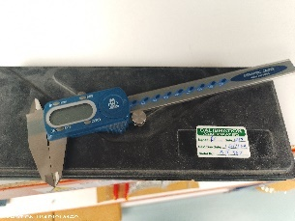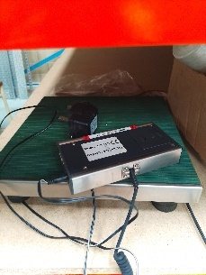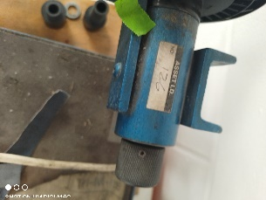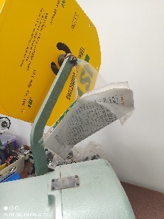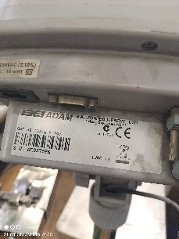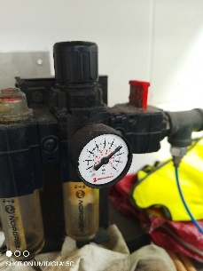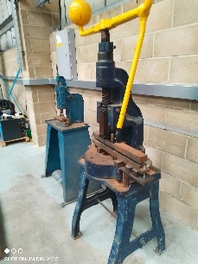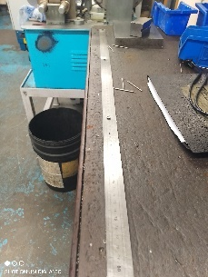

Toolboards
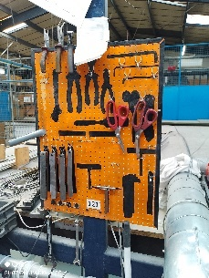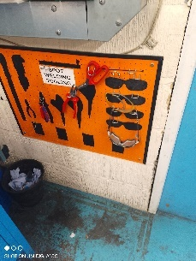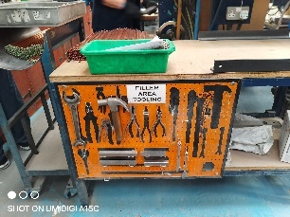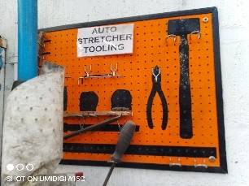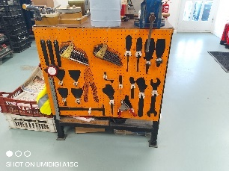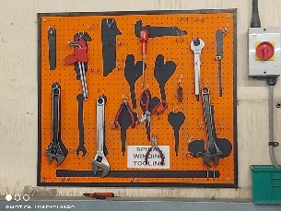
Equipment Calibration and maintenance. Dirty equipment with records on top from 2015
Materials/Stock Items
Stock Items
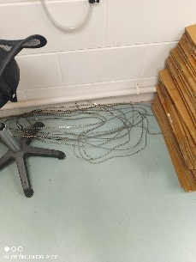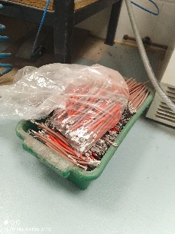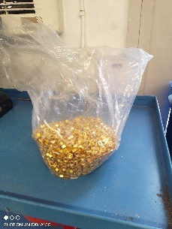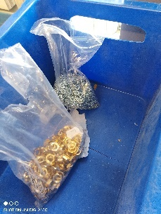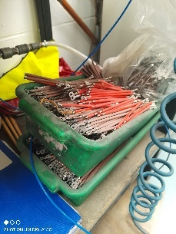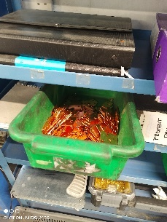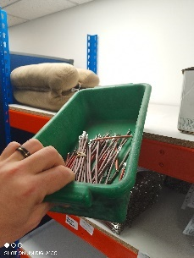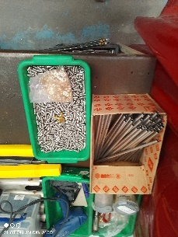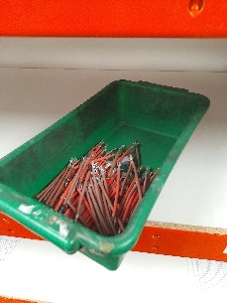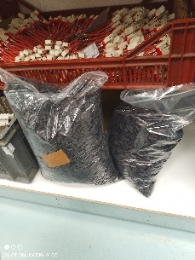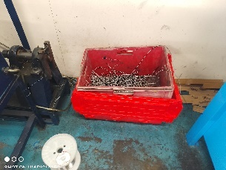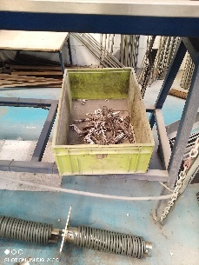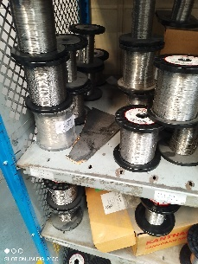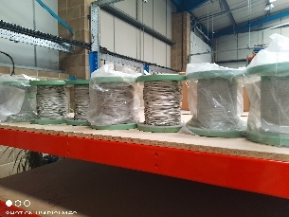

Materials
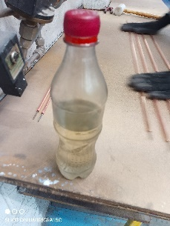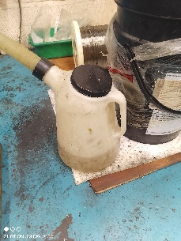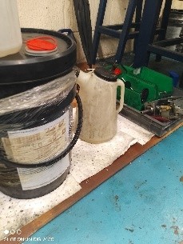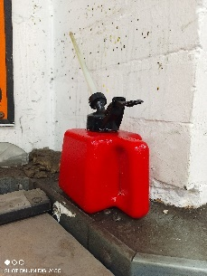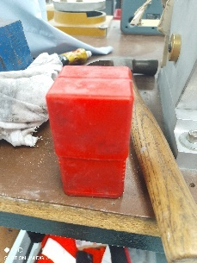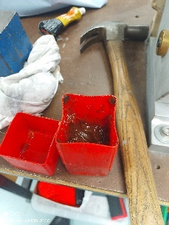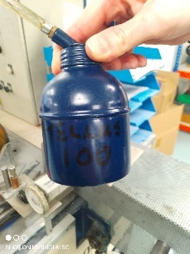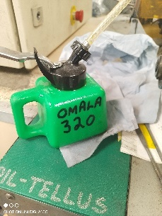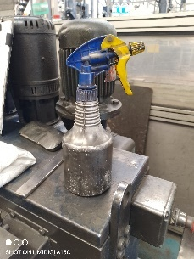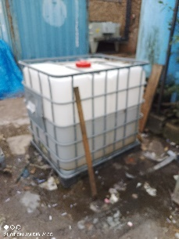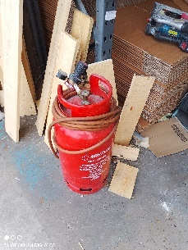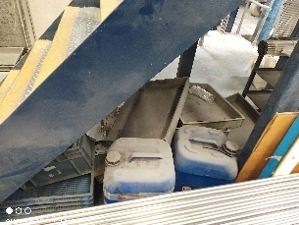

NonConforming materials
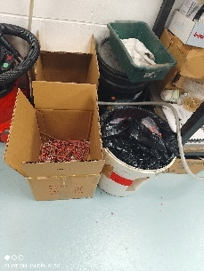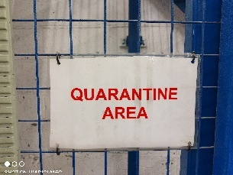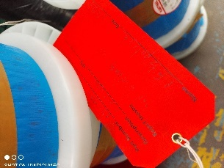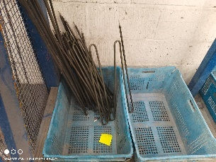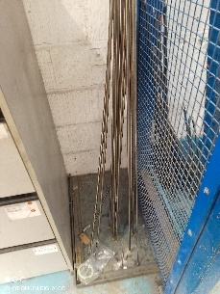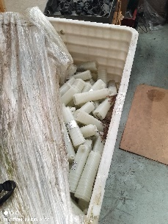
Stock not labelled up, materials used not labelled up, quarantine stock not labelled up
Site (Preservation/Standards etc…)
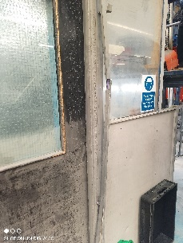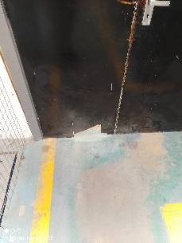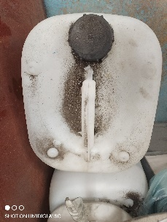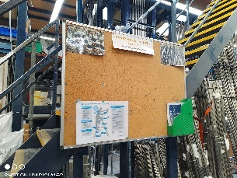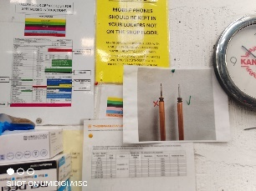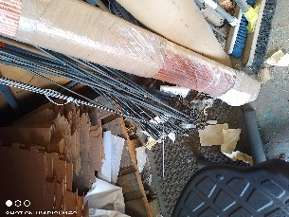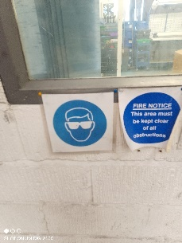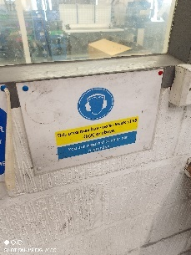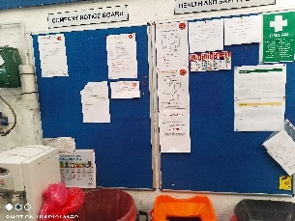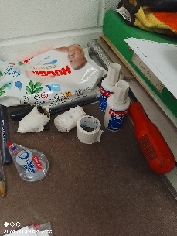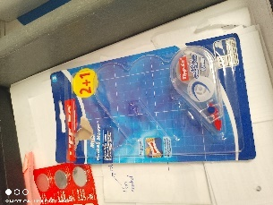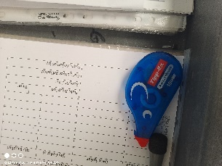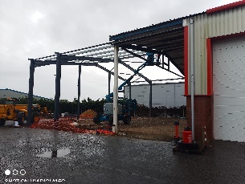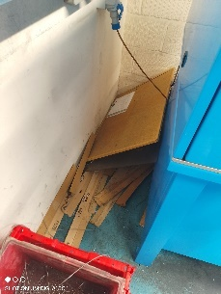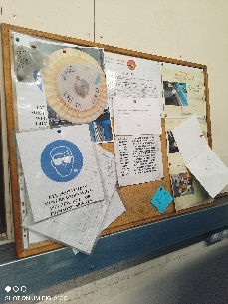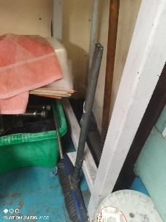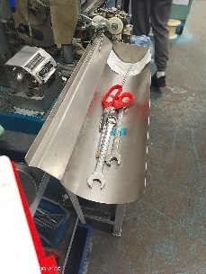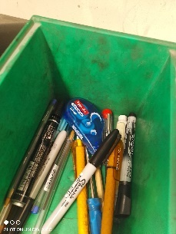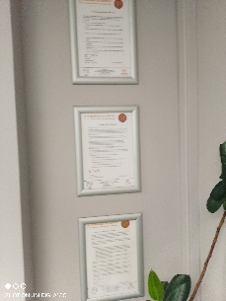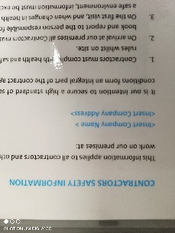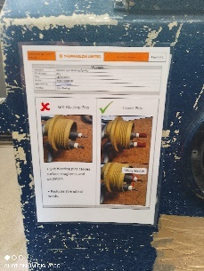
Use of tippex, overload of signs and notice boards. Hygiene standards
Goods In/Out Traceability
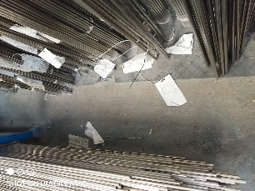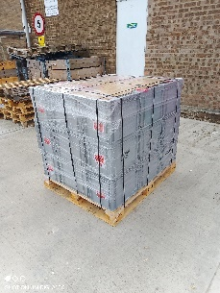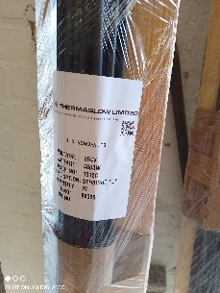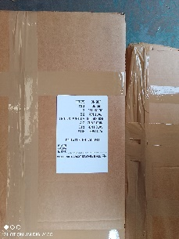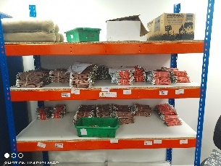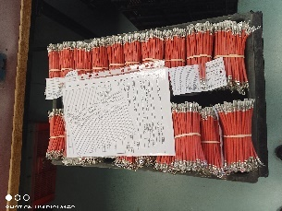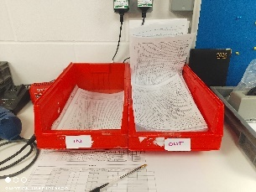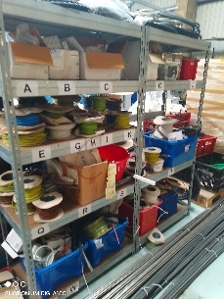
Please note: Traceability exercise and Quality manual notes merged from scans of the document.

Section 6: Client’s acknowledgement
The client acknowledges the content in the report and the attached findings. The client also understands that the findings are based on a sample and are not comprehensive of the entire system.
Name
Address

